Primary Sources: Lincoln Declares Thanksgiving a National Holiday
NAME:
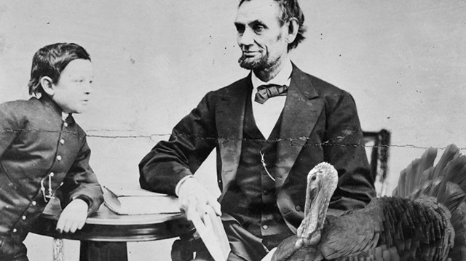
Editor's Note: For the first 93 years of its existence, the United States did not celebrate Thanksgiving as we do today. George Washington did proclaim a national day of thanksgiving in 1789. However, it was only for that year.
GIST
GIST
President Abraham Lincoln proclaimed several days of thanksgiving during his time in office. For example, on November 28, 1861, he ordered government departments closed for Thanksgiving. His order did not apply to the nation as a whole, however, but only to government workers in the capital.

By 1863, Lincoln had decided it was time to do something more lasting, and on a nationwide scale. The country was then in the middle of the Civil War, and hundreds of thousands of soldiers were away from home. Lincoln realized that many Americans would appreciate an annual homecoming that would allow families to gather together. On October 3, he proclaimed an annual day of Thanksgiving, to be observed from then on.
GIST
GIST
Lincoln did not come up with the idea entirely on his own, however. It originated with Sarah Josepha Hale, a 74-year-old magazine editor. Hale was most famous for writing "Mary Had a Little Lamb."

On September 28, 1863, Hale wrote Lincoln a letter. In it, she urged the president to have the "day of our annual Thanksgiving made a National and fixed Union Festival." She explained, "For some years past, there has been an increasing interest felt in our land to have the Thanksgiving held on the same day, in all the States."
GIST
GIST
Before 1863, Thanksgiving was mainly celebrated in New England and other Northern states. Furthermore, each state chose when to celebrate it, so it was not celebrated at the same time.

In her letter to Lincoln, Hale mentioned that she had been pushing for a national thanksgiving date for 15 years. Six previous presidents had ignored her request completely. Unlike them, President Lincoln responded immediately.
GIST

The document below is Lincoln's official declaration of a new national day of thanksgiving. It was written by Secretary of State William Seward on Lincoln's behalf. The original manuscript was in Seward's handwriting and was sold one year later to benefit Union troops.
GIST

MAIN IDEA OF ARTICLE
TARGET VOCABULARY:
PROCLAIM ANNUAL ORIGINATED URGED
REQUEST DECLARATION BENEFIT

PRIMARY SOURCE

"These Riches Are So Constantly Enjoyed"
Washington, D.C., October 3, 1863
By Abraham Lincoln, President of the United States of America

A Declaration
GIST

The year that is drawing towards its close has been filled with the blessings of fruitful fields and healthful skies. These riches are so constantly enjoyed that we oftentimes take them for granted. To these bounties others have been added. They are of so marvelous a nature that they cannot fail to soften even the hardest heart.

We are in the midst of a terrible Civil War, which has sometimes seemed an invitation to foreign countries to attack us. Yet, peace has been preserved with all nations. At home, order has been maintained, the laws have been respected and obeyed, and harmony has prevailed everywhere except on the battlefield. Meanwhile, the areas in which fighting continues have shrunk steadily as the armies of the Union advance.
GIST
Despite the war, our nation has not stopped its steady, upward climb. Forests have been cleared, enlarging the borders of our settlements, and mines have yielded riches even more abundantly than before. Our population has steadily increased, despite all the losses on the battlefield. Our country is rejoicing in its increasing strength and vigor.
GIST

"This Most Dreadful War"

These great things were not brought to us by any human hand or mind. They are the gracious gifts of the Most High God. It seems to me fit and proper that the whole American people should, with one voice, solemnly, reverently and gratefully give thanks for these blessings. I do therefore invite my fellow citizens in every part of the United States to observe the last Thursday of November as a day of Thanksgiving and praise to our generous Father.
GIST

As we offer praise for our own blessings, we must think of others less fortunate. Let us humbly ask the Lord to care for all those who have become widows or orphans during this most dreadful war. Let us also beseech the Almighty to heal the wounds of the nation, and restore our land to a state of peace, harmony, and Union.
GIST

Done at the City of Washington, this Third day of October, in the year of our Lord one thousand eight hundred and sixty-three, and of the Independence of the United States the Eighty-eighth.
GIST

MAIN IDEA OF ARTICLE
TARGET VOCABULARY:
FRUITFUL BOUNTIES MIDST PREVAILED
YIELDED VIGOR REVERENTLY FORTUNATE
Why is the text above considered a PRIMARY SOURCE?

