CCM6 and CCM6PLUS Name________________________________
Distance and Geometry in the Coordinate Plane Review Date____________ Pd_______
Plot the points and determine the quadrant number.

A (4, 7) Quadrant _______
B (-5, 2) Quadrant _______
C (-1, -6) Quadrant _______
D (8, 3) Quadrant _______
E (0, -2) Quadrant ________

Fill in the blank:
6) In Quadrant I, x is ______________ and y is _________________.
7) In which Quadrant is x positive and y is negative? ____________________.

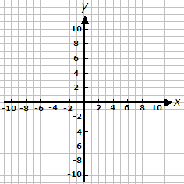
Find the distance between the following points.
Use the graph if needed.

8. (2, 3) and (2, -10) _________ 11. (7, 6) and (7, -1) _________
9. (-8, 0) and (3, 0)_________ 12. (-9, 6) and (-2, 6) _________

10. (-1, 10) and (-4, 10)_________ 13. (3, $-2\frac{1}{5}$) and (3 , 7 $\frac{1}{3}$)_________

Complete the table, using the original point as your starting point.

Point | Reflect Across X-Axis | Reflect Across Y-Axis
(7,-2)
(-6,-4)
(3, 8)
(-5,8)

