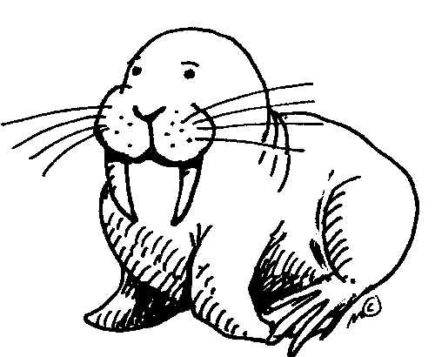
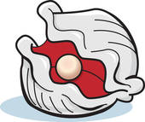
The Walrus and the Carpenter by Lewis Carroll
Pg. 532

Poetry Elements Practice: Find an example of each of the following from the text.

 | Example in text | Page #, line and stanza
- Alliteration
- Repetition
- Personification
- Rhyme

EOG Practice Questions: Choose the best answer for each question

- The excerpt is an example of what genre of literature?
- Short story
- Drama
- Autobiography
- Poetry

- Which characteristics of the selection is specific to its genre?
- It includes figurative language
- It is arranged in short lines
- It tells a story
- It presents information about a topic

- Which word best describes the tone of the selection?
- Solemn
- Humorous
- Angry
- Sorrowful

- Which synonym fits the meaning of scarcely used in line 107 in the last stanza?
- Very
- Happily
- Pleasantly
- Hardly

- What event is foreshadowed by the eldest Oyster’s refusal to leave the oyster bed?
- The Walrus and the Carpenter take the oysters for a walk
- The Oysters escape from the Walrus and the Carpenter
- The Walrus and the Carpenter eat the Oysters
- The Walrus and the Carpenter take the Oysters home with them

- Which word best describes a theme of this selection?
- Betrayal
- Hunger
- Beauty
- Love

Reading Comprehension Questions:

- Why is the moon angry at the sun? Cite a line from the poem that proves the moon is angry.

- Reread lines 37-42. The eldest Oyster lived longer than most oysters because:

- In lines 73-78 what is the Walrus listing that he needs? Why do you think he needs these items?

- If the story was told from the perspective of the Oysters, how would the mood be different?

- How were the oysters tricked and what might the author tell you to do to avoid being tricked? Provide support and explanations from the poem.

