Name:___________________________________
Weekly Spiral Questions – Quarter 4 Week 5
Show all work on a separate paper and attach it to the back. Be sure to label your answers appropriately! (Calculator Inactive)
1. Given 184%, what is the equivalent fraction and decimal in simplest form? | Answer  Fraction: ________  Decimal: _________
2. A meteorologist found the following temperatures in Grand Rapids, Michigan for one week. Which day was the coldest? Which was the warmest?  Day Temperature  Monday -3.2º F  Tuesday -3º F  Wednesday 0.2º F  Thursday 0º F  Friday -0.7º F  Saturday -6º F  Sunday -5.6º F | Answer  Coldest: _________  Warmest: _________

3. Use GCF to find the missing width and length(s) of the figure below. Write the values on the given lines.  ________ _______  35x 21 | Answer:
4. Simplify.  $$\frac{36x}{3}+3(4x+2)$$ | Answer:

5. In a cookie mix, the ratio of cups of peanut butter chips to cups of chocolate chips is 2:5. How many cups of peanut butter chips would be needed for 45 cups of chocolate chips? | Answer:
6. Dedra and Julie ended up making the same number of cookies for a bake sale at school, even though Dedra made them in batches of 14 cookies and Julie made them in batches of 20 cookies. What is the smallest number of cookies each must have baked? | Answer:

7. Calculate Perimeter  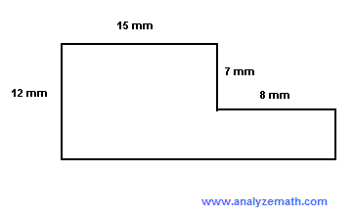 | Answer:
8. What is the Area of the figure in #7? | Answer:

