Name:___________________________________
Weekly Spiral Questions – Quarter 4 Week 4
Show all work on a separate paper and attach it to the back. Be sure to label your answers appropriately! (Calculator Inactive)

1. The table shows the cost of buying a certain number of items.  Item Quantity Total Cost  Apple 10 $7.50  Banana 4 $3.28  Grapefruit 6 $5.04  Orange 8 $7.20  What item has the highest price per unit and what is the price per unit? | Answer  Item:_______  Price per unit:_____
2. Riley can do 6 math problems in 20 minutes. How many math problems can Riley complete in 3 hours at this rate? | Answer:

3. In a bag of mini candy bars, 40% of the candy bars are Snickers. There are 120 Snickers in the bag. How many total mini candy bars are in the bag? | Answer:
4. A jar of grape jelly costs $6.95 plus tax. After sales tax, the jar of grape jelly costs $7.30. What is the sales tax rate? (your answer should be a percentage!) | Answer:

5. In which Quadrant does the point (7, -3) lie? | Answer:
6. Find the area of triangle ABC.  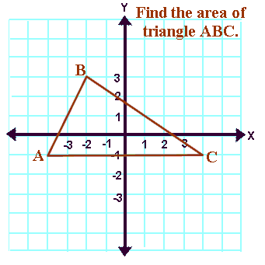 | Answer:

7. Find the area of the trapezoid.  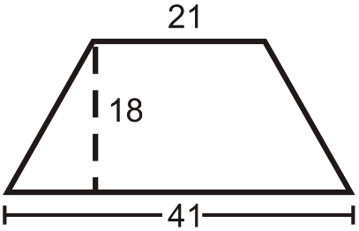 | Answer:
8. Find the difference between $5\frac{4}{5}$ and $7\frac{1}{3}$. | Answer:

