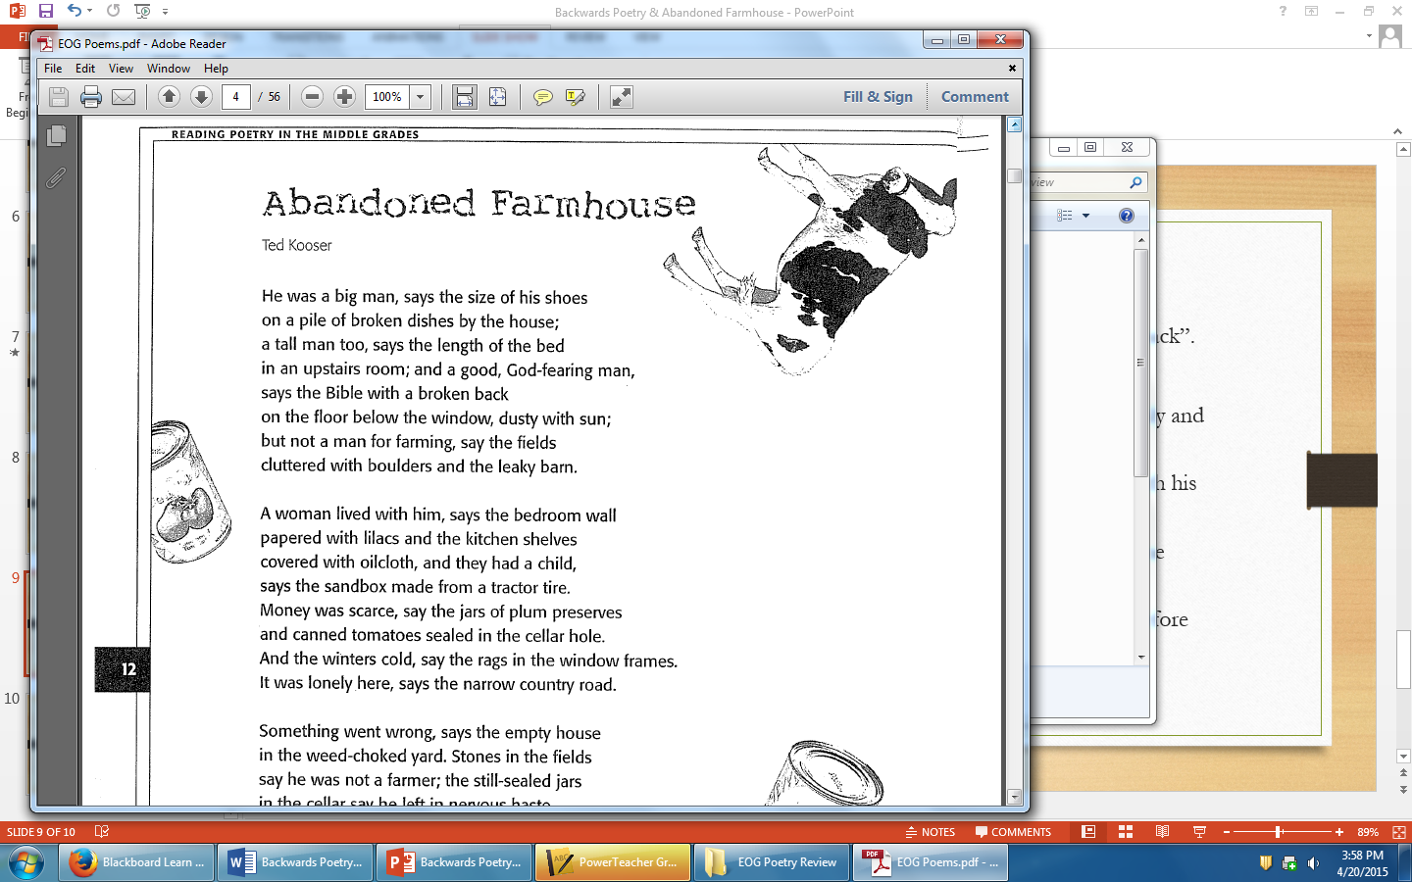

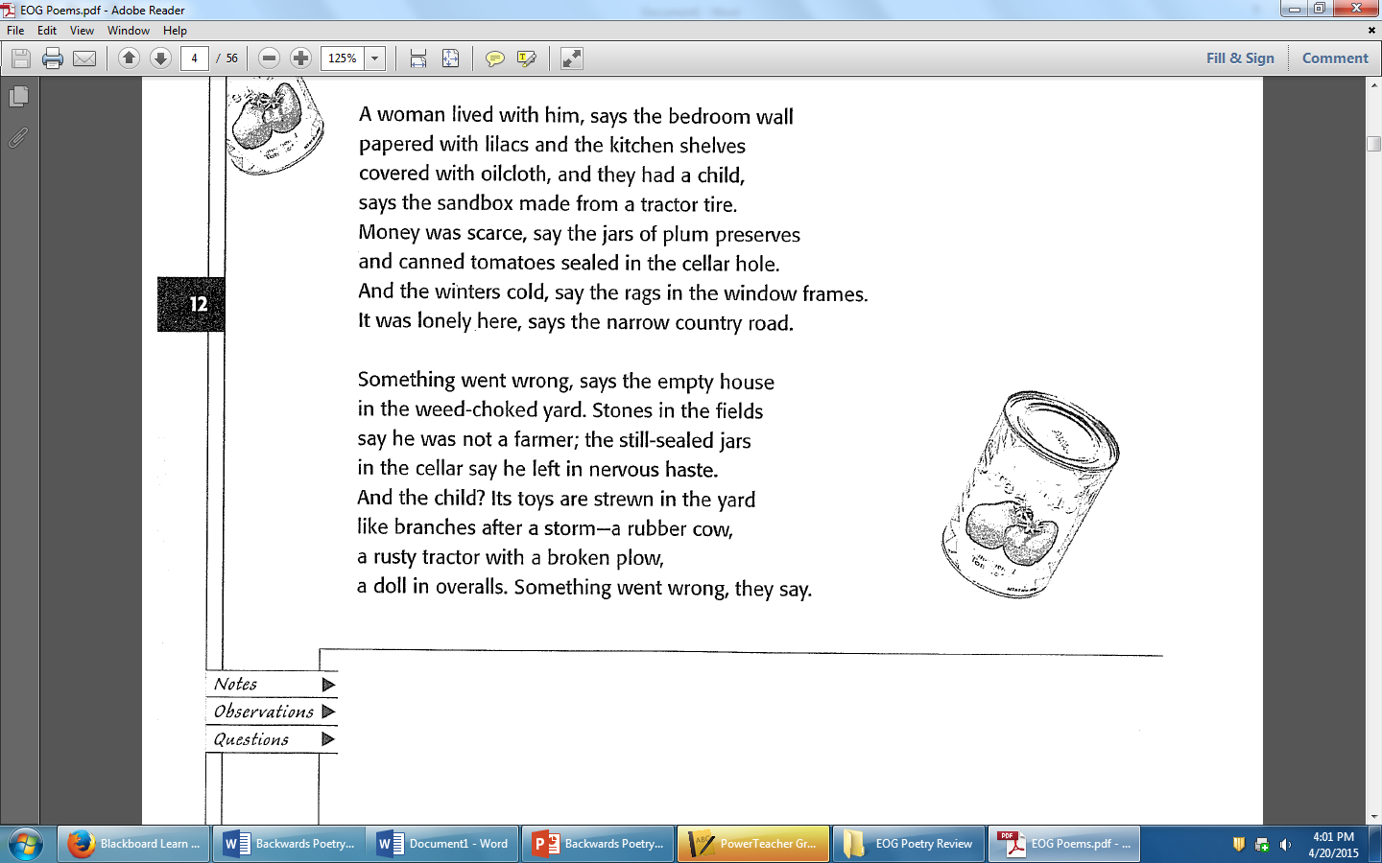

|  |  |
| --- | --- |
| **Notes**  **Observations**  **Questions** |  |